Move Down / Right
Marinette has the ability to transform into Ladybug. She is stuck on a grid. Her initial location is at the top-left corner and tries to move to the bottom-right corner. However, she can only move either down or right at any point in time.
Write a program that prints the number of all possible unique paths that Marinette can take to reach the bottom-right corner.

Input
- On the first line you will receive an integer – m – number of rows.
- On the second line you will receive an integer – n – number of cols.

Output
- Print the number of all possible unique paths to the bottom-right corner.

Constraints
- m and n will always be in the range [0… 1000].

Examples
Input | Output | Comments
3  2 | 3 | All possible unique paths:  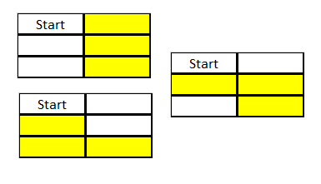
3  5 | 15
35  12 | 10150595910

